AWS Automation with Lambda & Boto3
_____________________________________________________________________________________________________
2.Automated EBS Snapshot Creation and Cleanup
Objective: Automate EBS volume backups and delete snapshots older than a retention period.
----------------------------------------------------------------------------------------------------------------------------------------
Step 1 – Create or Identify an EBS Volume
Option A – Use an Existing Volume
- Login to AWS Console.
- Open EC2.
- In the left menu, select Volumes.
- Note the Volume ID.
Example:
vol-0bf721c5b1ed31789

Step 2 – Create IAM Role for Lambda
Go to:
IAM
→ Roles
→ Create Role
Choose
AWS Service
Select
Lambda
Click Next.
Role Name:
EBSBackupLam bdaRole
Create the role.

Step 3 – Attach CloudWatch Policy
Attach the managed policy:
AWSLambdaBasicExecutionRole
This allows Lambda to write logs to CloudWatch.

Step 4 – Add Inline IAM Policy
Open the role.
Go to
Permissions
→ Add Inline Policy
→ JSON
Paste the following policy:
{
"Version": "2012-10-17",
"Statement": [
{
"Sid": "SnapshotPermissions",
"Effect": "Allow",
"Action": [
"ec2:CreateSnapshot",
"ec2:DescribeSnapshots",
"ec2:DeleteSnapshot",
"ec2:CreateTags"
],
"Resource": "*"
}
]
}
Save the policy.

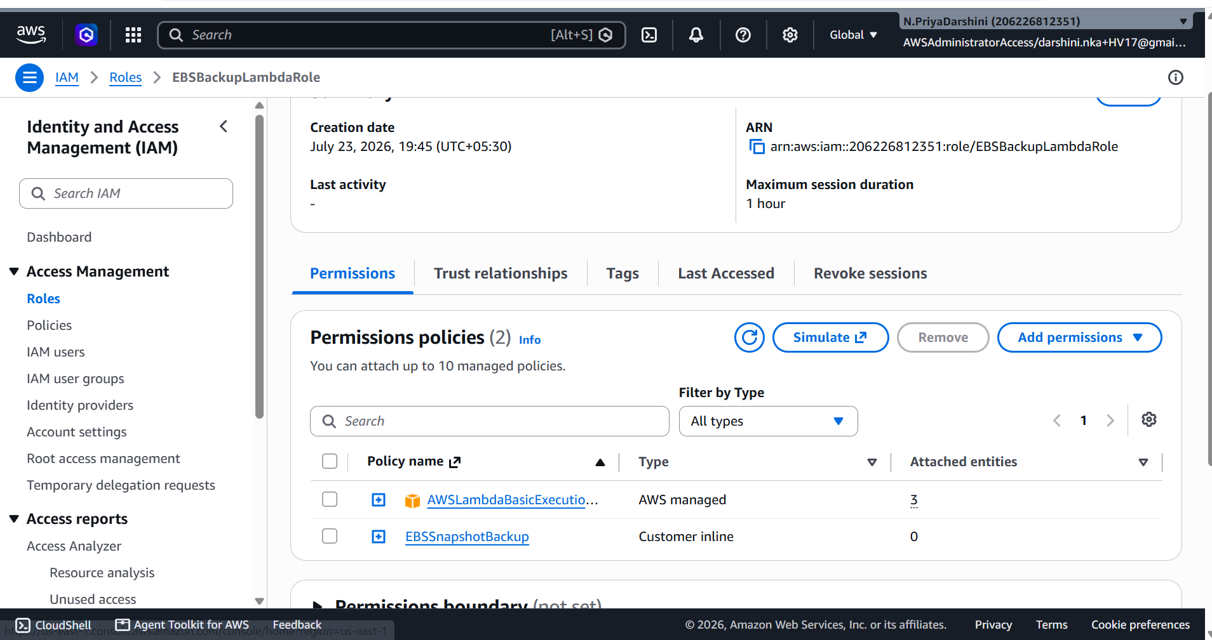

Step 5 – Create Lambda Function
Open
AWS Lambda
Click
Create Function
Choose
Author from Scratch
Configure:
Setting | Value
Function Name | EBSSnapshotBackup
Runtime | Python 3.12
Execution Role | Use Existing Role
Role | EBSBackupLambdaRole
Click Create Function.

Step 6 – Lambda Python Code
Replace the default code with the following:
import boto3
from datetime import datetime, timedelta, timezone

ec2 = boto3.client("ec2")

# Replace with your EBS Volume ID
VOLUME_ID = "vol-0123456789abcdef0"

# Testing:
# RETENTION = timedelta(minutes=5)

# Production:
RETENTION = timedelta(days=30)

def lambda_handler(event, context):

now = datetime.now(timezone.utc)

# Create Snapshot
snapshot = ec2.create_snapshot(
VolumeId=VOLUME_ID,
Description="Automated Lambda Backup"
)

snapshot_id = snapshot["SnapshotId"]

# Tag Snapshot
ec2.create_tags(
Resources=[snapshot_id],
Tags=[
{
"Key": "CreatedBy",
"Value": "Lambda-Backup"
}
]
)

print(f"Created Snapshot: {snapshot_id}")

deleted = []

paginator = ec2.get_paginator("describe_snapshots")

pages = paginator.paginate(
OwnerIds=["self"],
Filters=[
{
"Name": "tag:CreatedBy",
"Values": ["Lambda-Backup"]
}
]
)

for page in pages:

for snap in page["Snapshots"]:

start_time = snap["StartTime"]

if now - start_time > RETENTION:

ec2.delete_snapshot(
SnapshotId=snap["SnapshotId"]
)

print(f"Deleted Snapshot: {snap['SnapshotId']}")

deleted.append(snap["SnapshotId"])

return {
"CreatedSnapshot": snapshot_id,
"DeletedSnapshots": deleted
}

Why Use a Paginator?
Although describe_snapshots() may return many snapshots, using a paginator ensures your Lambda processes all pages of results, making it scalable for large environments.

Step 7 – Deploy Lambda
Click
Deploy

Step 8 – Create a Test Event
Click
Test
Create a new event.
Example:
{}
Save it.

Step 9 – Manual Testing
For testing, temporarily change:
RETENTION = timedelta(minutes=5)
Deploy again.
Run the Lambda manually.
Expected behavior:
- A new snapshot is created.
- Any tagged snapshots older than five minutes are deleted.
- Snapshot IDs are printed in the logs.
After testing, restore:
RETENTION = timedelta(days=30)
and deploy again.

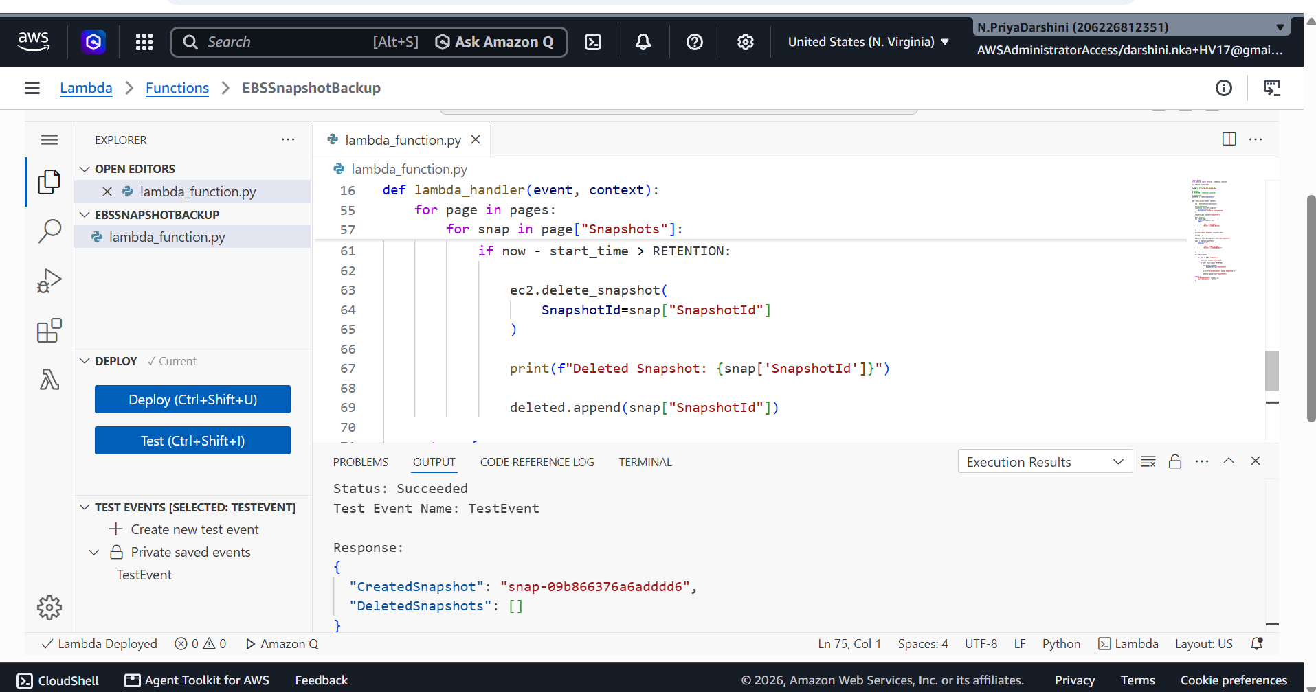

Step 10 – Verify Snapshot Creation
Open:
EC2
→ Snapshots
Confirm:
- A new snapshot exists.
- The snapshot has the tag:
CreatedBy = Lambda-Backup

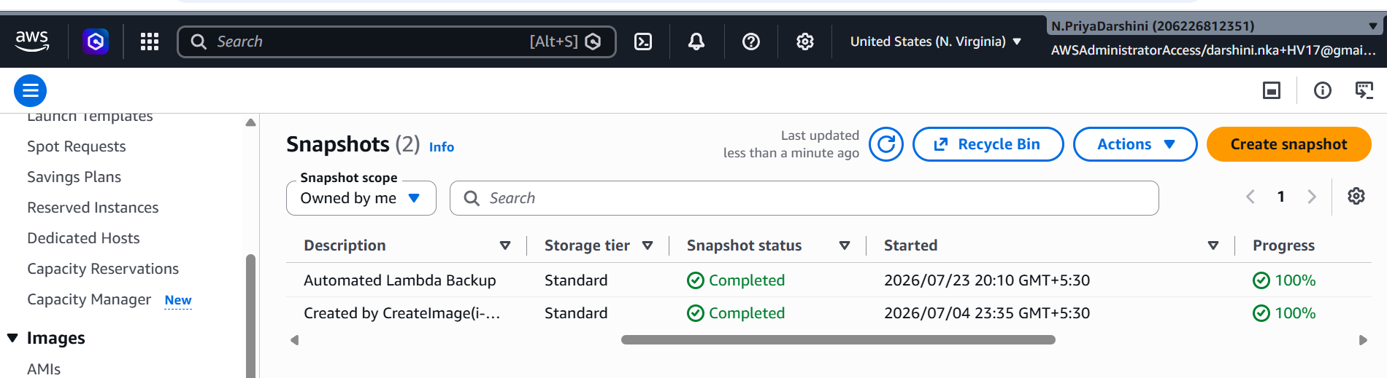

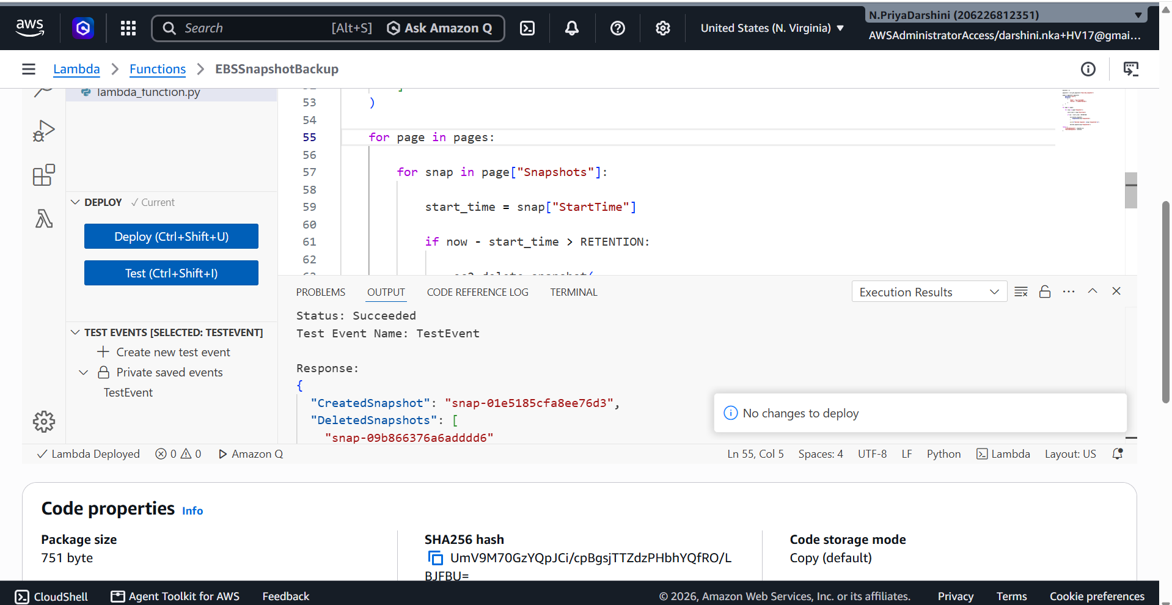

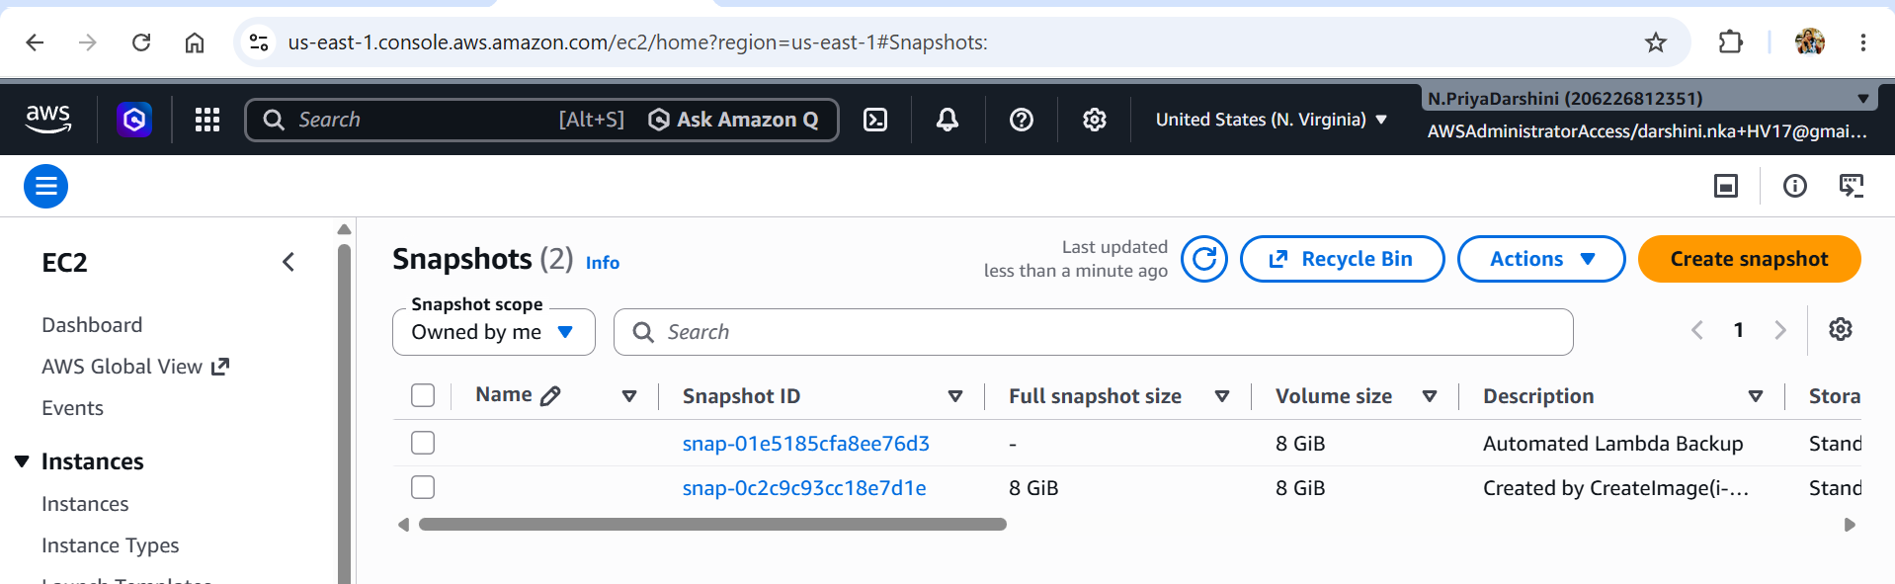

Step 11 – Verify Cleanup
If older tagged snapshots exist (older than the configured retention period), they should no longer appear in the Snapshots page after the Lambda runs.

Step 12 – View CloudWatch Logs
Navigate to:
CloudWatch
→ Log Groups
→ /aws/lambda/EBSSnapshotBackup
Example log:
Created Snapshot: snap-0ab1234567890cdef

Deleted Snapshot: snap-01234567890abcde1

Deleted Snapshot: snap-0fedcba9876543210

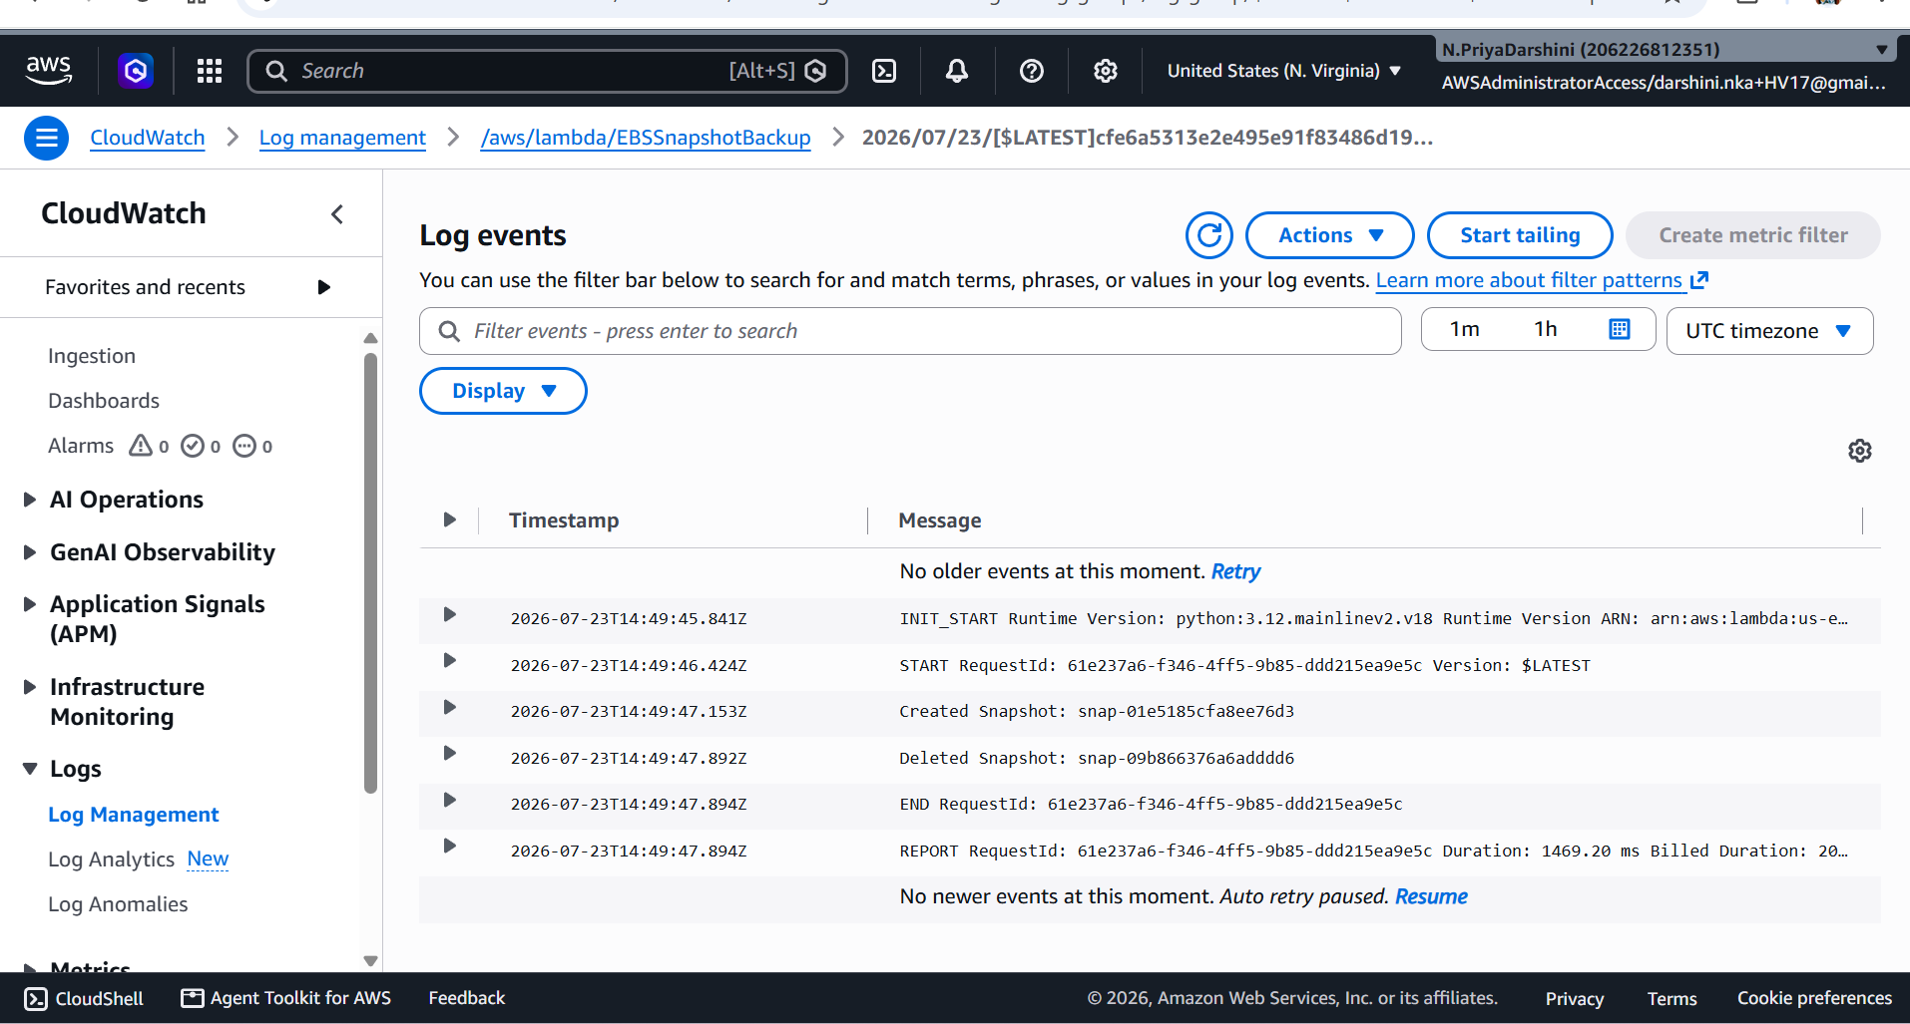

Step 13 – Configure EventBridge Schedule
Open:
Amazon EventBridge
Go to:
Rules
→ Create Rule
Configure:
Setting | Value
Rule Name | WeeklyEBSBackup
Event Bus | Default
Rule Type | Schedule
Choose:
Recurring Schedule
For a weekly backup, you can use:
Option 1 – Cron Expression
cron(0 2 ? * SUN *)
This runs every Sunday at 02:00 UTC.
Option 2 – Rate Expression
rate(7 days)
Select:
Target
→ Lambda Function
Choose:
EBSSnapshotBackup
Click Create Rule.

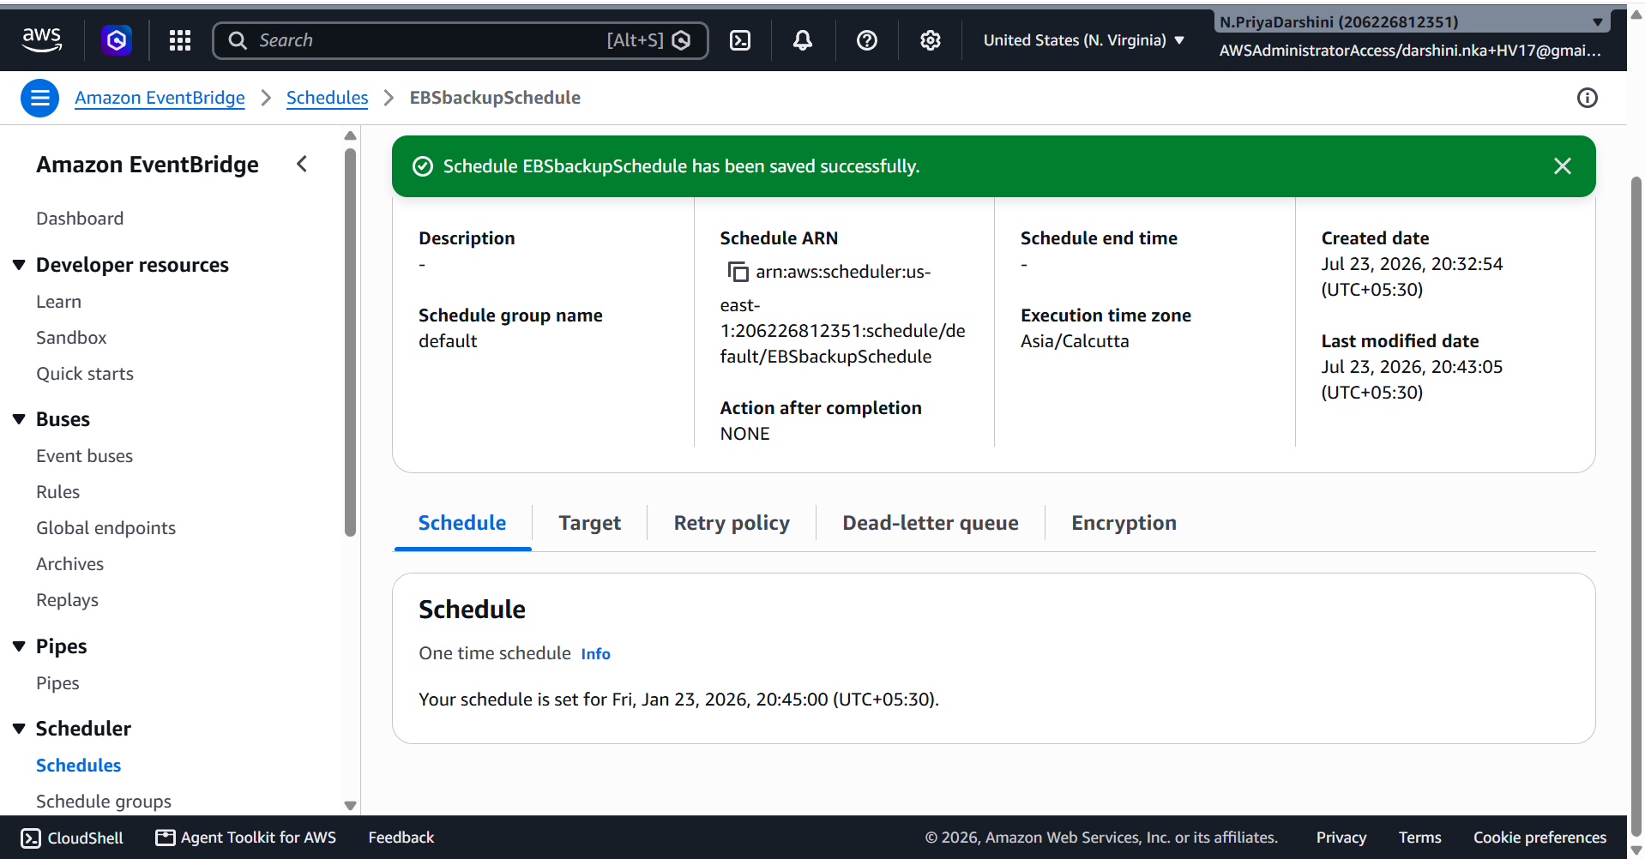

Step 14 – Test Scheduled Execution
You can:
- Wait for the scheduled execution, or
- Use Run Rule (if available in your console) or manually invoke the Lambda to validate the configuration.
Verify:
- A new snapshot is created.
- Old tagged snapshots are removed.
- CloudWatch logs contain the expected output.
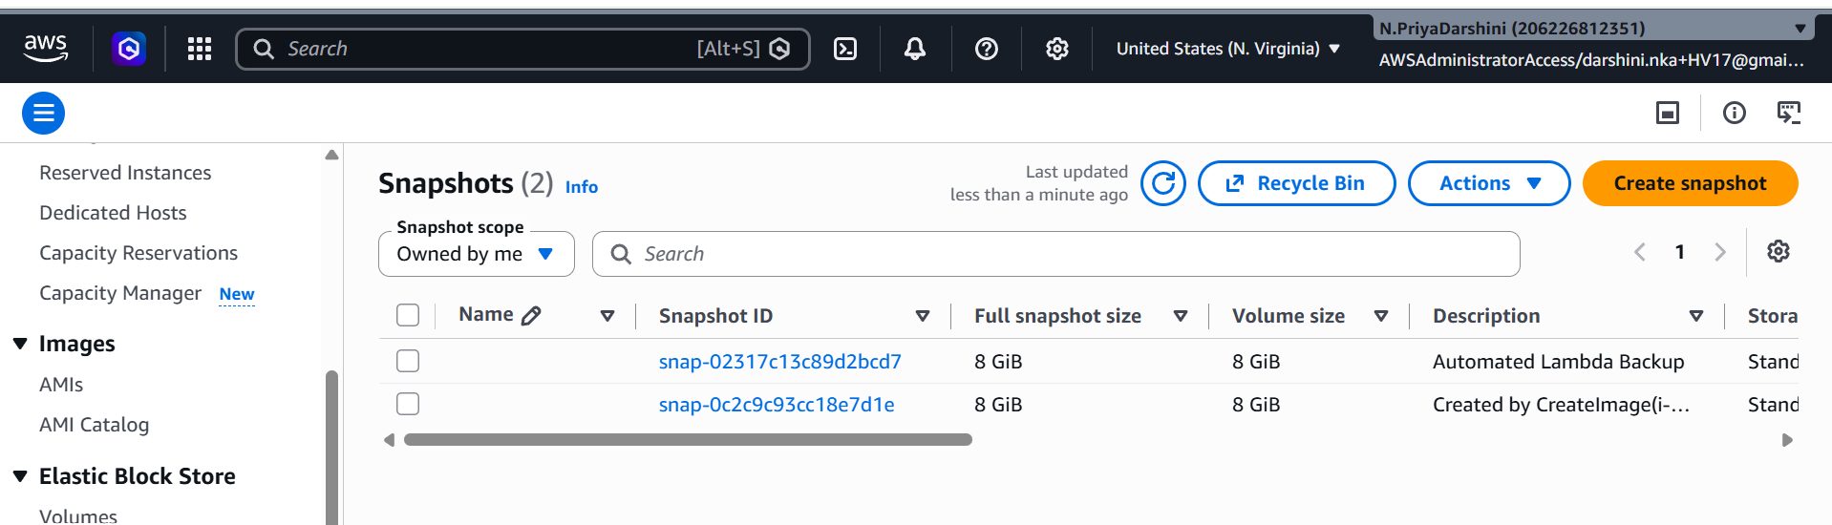

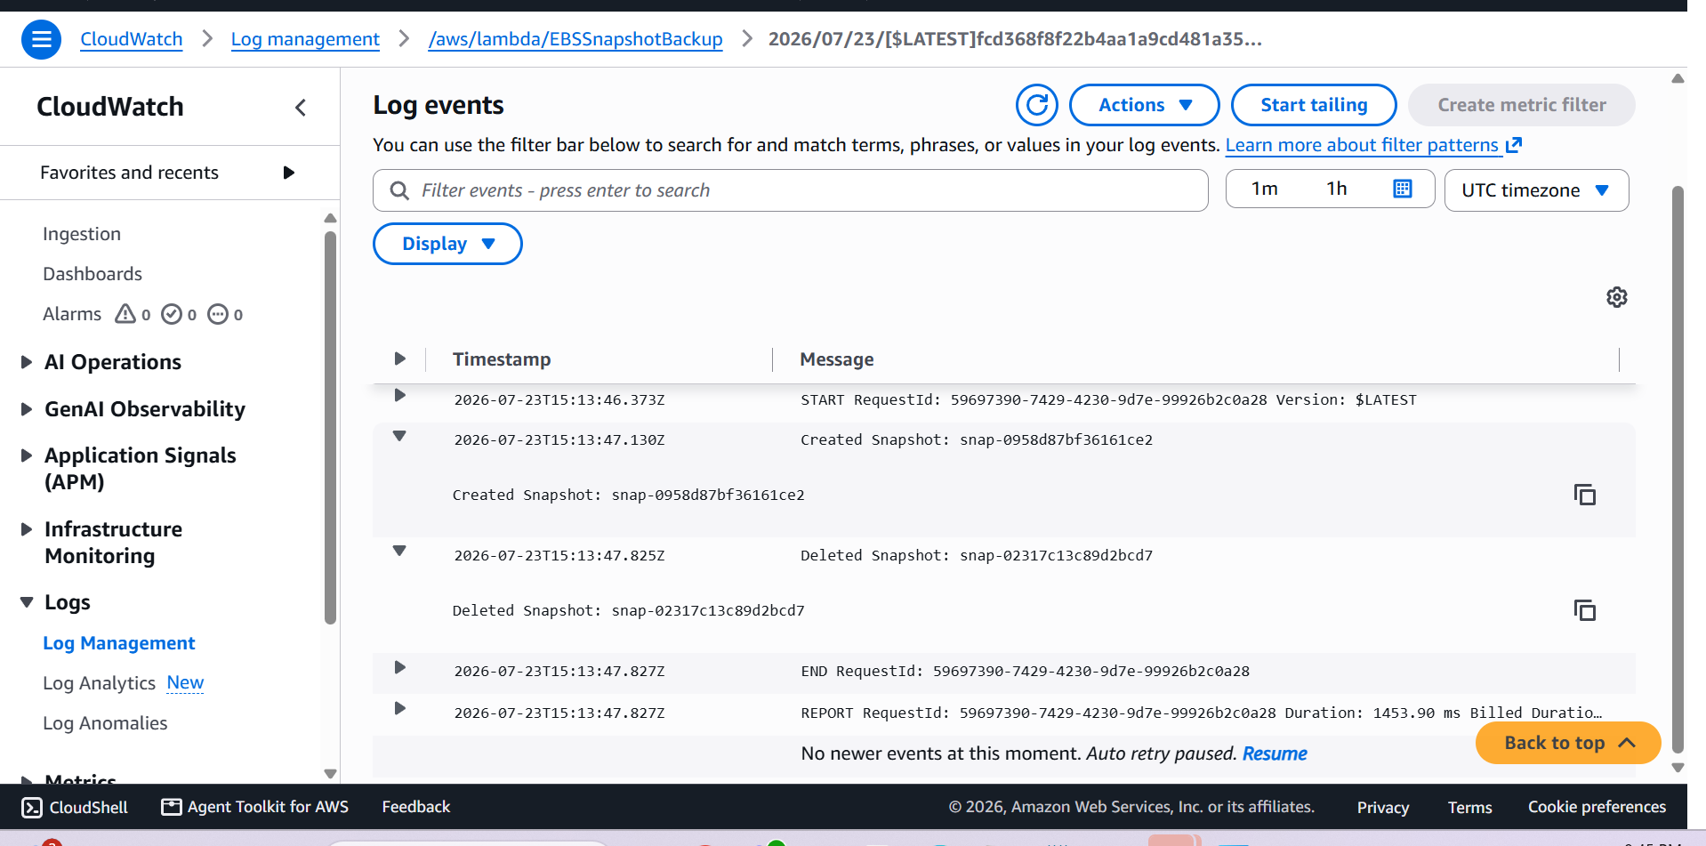

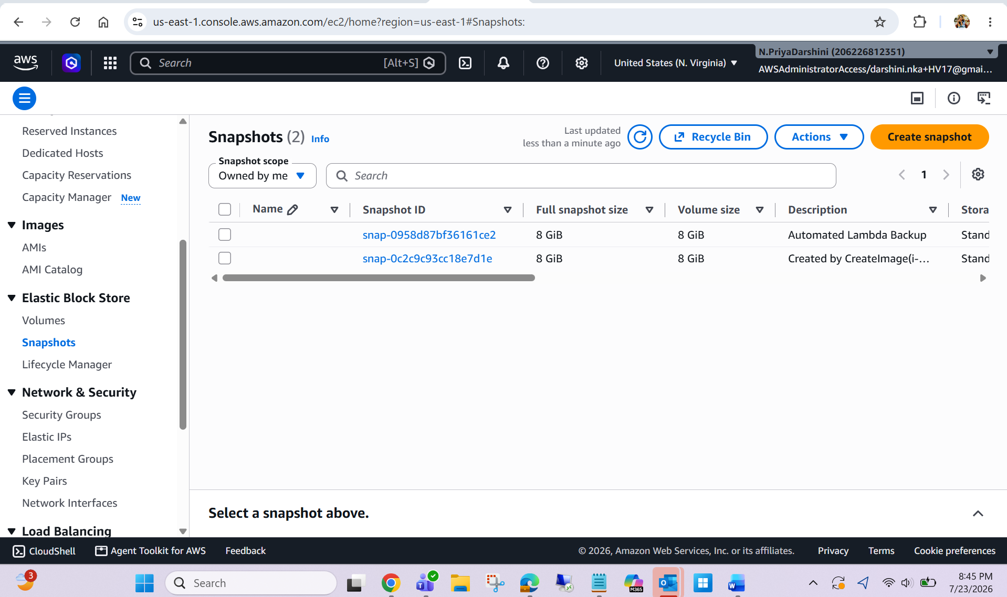

Discussion:

DLM as the default solution for standard snapshot lifecycle management and recommend Lambda only when additional customization or orchestration is required. This avoids unnecessary operational overhead from maintaining custom automation where AWS already provides a managed capability.

*********************************END***************************************************

